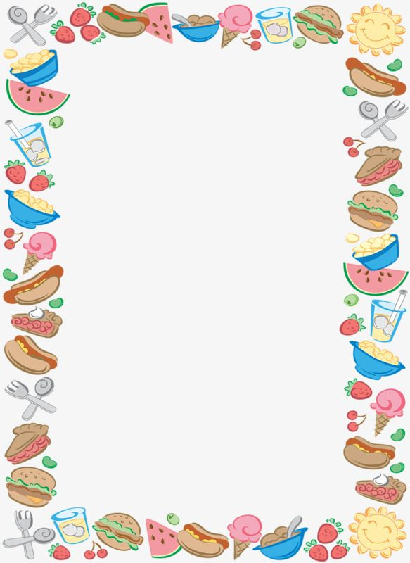

School Lunch Menu provided by
Deli Connection/Jobs Unlimited

October 31 to November 25, 2022

Halloween Special – October 31st
Witch Hair Pasta, witch fingers and eyeball Jello $5.00

Monday
Grilled Cheese sandwich with fruit & veggies $4.35
Pizza bagel (on ½ a bagel) with fruit & veggies $4.25

Tuesday
Chicken Quesadilla with fruit & veggies $5.00
Chicken Teriyaki Stir Fry and Rice with fruit $5.00

Wednesday
mini muffins (3) $1.50
Yogurt $ .75
Smoothie $2.25
Mini Cinnamon Pancake poppers (3) $1.50

Thursday
Spaghetti ground beef in sauce, half slice garlic bread with fruit & veggies $4.75
Veggie Wrap (Tomato, lettuce, cheese, mayo) with fruit & veggies $4.50

Friday
Pizza (cheese pizza) (1 slice) with fruit & veggies $4.50
Nachos chips with grated cheese, sour cream, salsa with fruit & veggies $4.50

